UNIT 11 HW
- From Problem 26, Chapter 8:

The Metabolic data set has the average mass, metabolic rate, and average lifespan of 95 different species of mammals. Kleiber’s Law states that the metabolic rate of an animal species, on average, is proportional to its mass raised to the power ¾. Judge the adequacy of this theory with these data. Ultimately, for this problem, we want to find the best model. (At this point, you will limit the analysis to the two variables under study, though the data set has more variables.) In the current data set, assume that mass has not yet been raised to the power ¾.
- Use alpha = 0.05.
- Use SAS for this problem.
- Include relevant code and output. Make sure you directly answer the questions. Do NOT assume the answer is obvious from the output.
Specifically, provide/answer the following:
    - Judging by a scatterplot alone, does it seem reasonable that the metabolic rate of an animal species, on average, is proportional to its mass raised to the power of ¾? (Recall that if some variable y is proportional to the variable x, then $\hat{y}=mx$ (with nonzero m) is a well-fitting model.) In other words, does the data (metabolic rate, mass^{3/4}) reasonably fall along a straight (nonhorizontal) line and nearly pass through the origin?
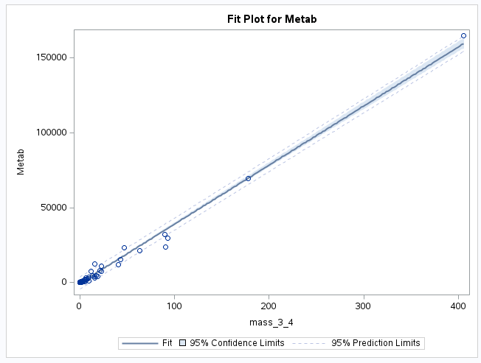
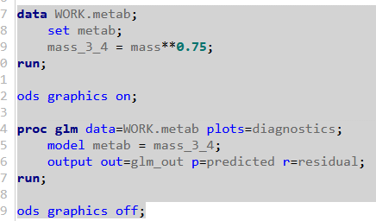
Yes, it is reasonable to say through visual means that the metabolic rate is proportional to the mass^.75, Every point near or at the regression line and the line itself also looks to cross intercept y at x:0 y:0, which would indicate that smaller animals would have smaller metabolic rate and vice versa.

    - We want to find the “best” model to predict metabolic rate from mass^{3/4} and make appropriate statistical inferences. Therefore, address all the assumptions prior to the analysis (using mass^{3/4}). If the assumptions are not met, handle the data appropriately. If a transformation is used to satisfy the assumptions, address the assumptions again to ensure that the transformation is logical, and carry out your analysis on your newly transformed data. For example, you should include a scatter plot for the original data AND transformed data, etc. (Hint: if a transformation is necessary, try one of the transformations discussed in class first.) Either way, keep the “mass^{3/4}” in the model; do not go back to regular “mass,” although mass^{3/4} may be transformed if it makes sense for the assumptions. At minimum, provide and interpret the following elements to address assumptions FOR THE ORIGINAL DATA AND ANY TRANSFORMED DATA (IF you use a transformation). You may include more graphs if you find them useful.
- A scatterplot with the following included on the graph: regression line, confidence intervals of the regression line, and prediction intervals of the regression line.
POST LOG-LOG Transformation
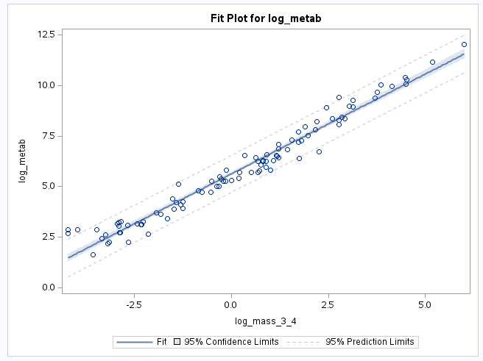
ii. A scatterplot of residuals.
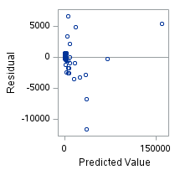
POST LOG-LOG Transformation
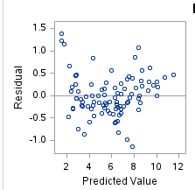
iii. A histogram of residuals with the normal distribution superimposed.
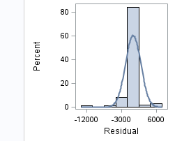
POST LOG-LOG Transformation
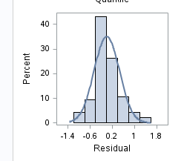
iv. A discussion supporting the use of the model you chose (support that the assumptions are met).
    - Initially looking at the data plotted without any transformation (barring the mass^¾). The data seemed to violate assumptions such as the homoscedasticity and normality of the data. After we transformed the data by using the natural log of both the x and y values, the data follows much closer to a normal distribution and the residuals seemed to be randomized around the residual line.
    - Once a reasonable model is found (possibly using a transformation), provide a table showing the t-statistics and p-values for the significance of the regression parameters $β_{0 }and β_{1}$.
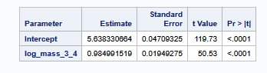
    - The estimated regression equation. Make sure the dependent variable is noted as the predicted value or predicted mean value, not just the dependent variable.
$Metab =β_{0 }+β_{1} * Mass^{3/4}$
$Metab =5.64+0.985( Mass^{3/4}$)
    - Interpretation of the model, paying special attention if you used a transformation (hint!). That is, interpret the slope as well as the confidence interval.
For every doubling of the Mass^¾ , the median metabolic rate multiplied by 2^$β_{1}$
For every doubling of the Mass^¾, there is an associated increase of 97% to the median
metabolic rate.
95% CI of $β_{1}$(.946282773, 2.033127)
For every doubling of the Mass^¾, we are 95% confident that the associated increase to the median metabolic rate is between 93% and 103%

    - A measure of the proportion of variation in the response that is accounted for by the explanatory variable. Interpret this measure clearly.
R^2= 0.964858
95% of the variation of the metabolic rate is explained by the mass^¾

CODE for Question 1
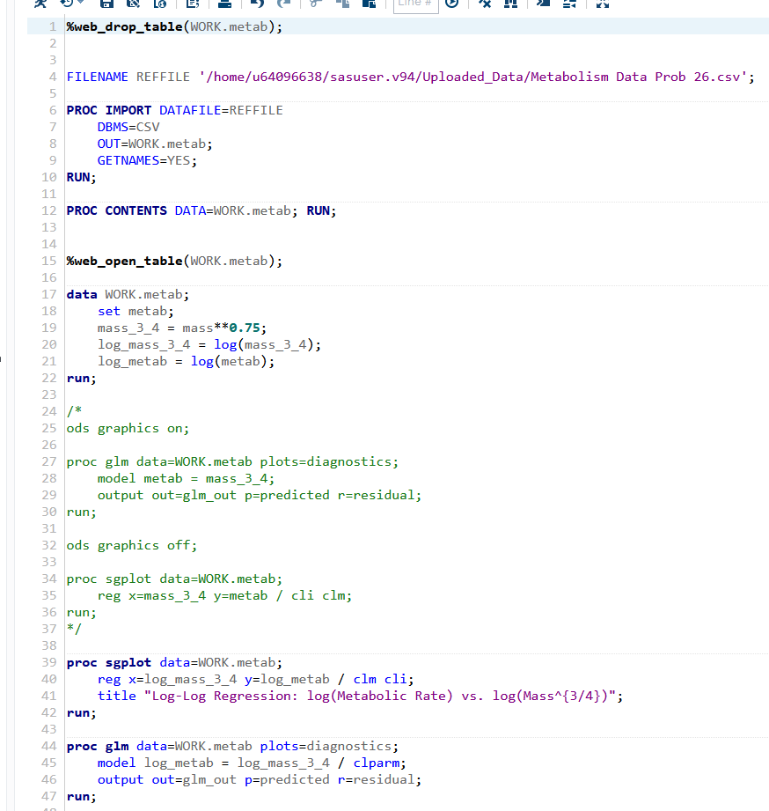

- From Problem 29, Chapter 8:
The autism data show the prevalence of autism per 10,000 ten-year-old children in the United States in each of five years. Analyze the data to describe the change in the distribution of autism prevalence per year during this time period.
- Use alpha = 0.05.
- Use R for this problem.
- Include relevant code and output. Make sure you directly answer the questions. Do NOT assume the answer is obvious in the output.
Specifically, provide/answer the following:
    - Address all the assumptions for a linear regression model prior to the analysis. If the assumptions are not met, handle the data appropriately. If a transformation is used, address the assumptions again with the transformed data to ensure that the transformation is logical. The questions below should reflect this. For example, you should include a scatter plot for the original data AND transformed data, etc. (Hint: if a transformation is necessary, try one of the transformations discussed in class first.) At minimum, provide and interpret the following elements to address assumptions FOR THE ORIGINAL DATA AND ANY TRANSFORMED DATA (IF you use a transformation). You may include more graphs if you find them useful.
- A scatterplot with the following included on the graph: regression line, confidence intervals of the regression line, and prediction intervals of the regression line.
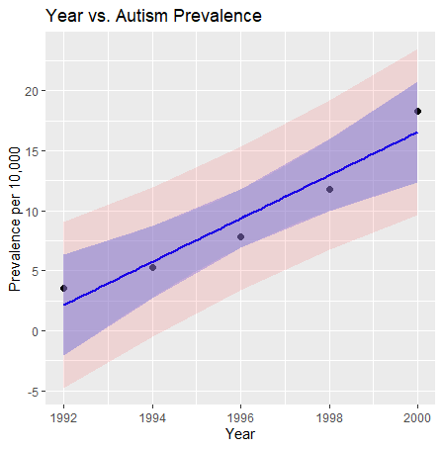 vs. 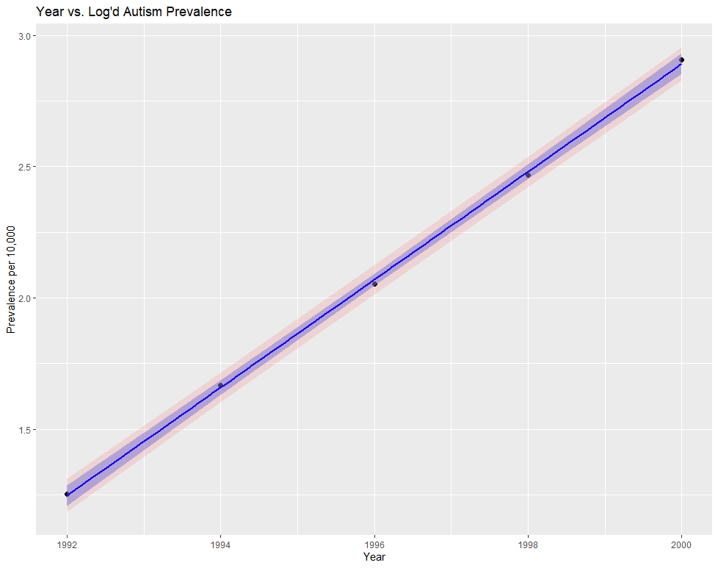
ii. A scatterplot of residuals.
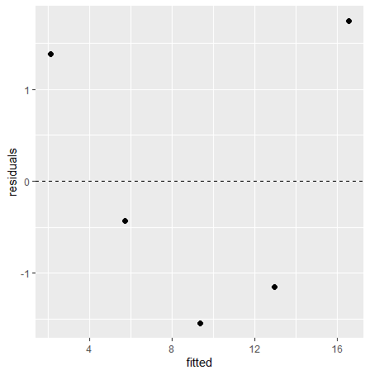vs. 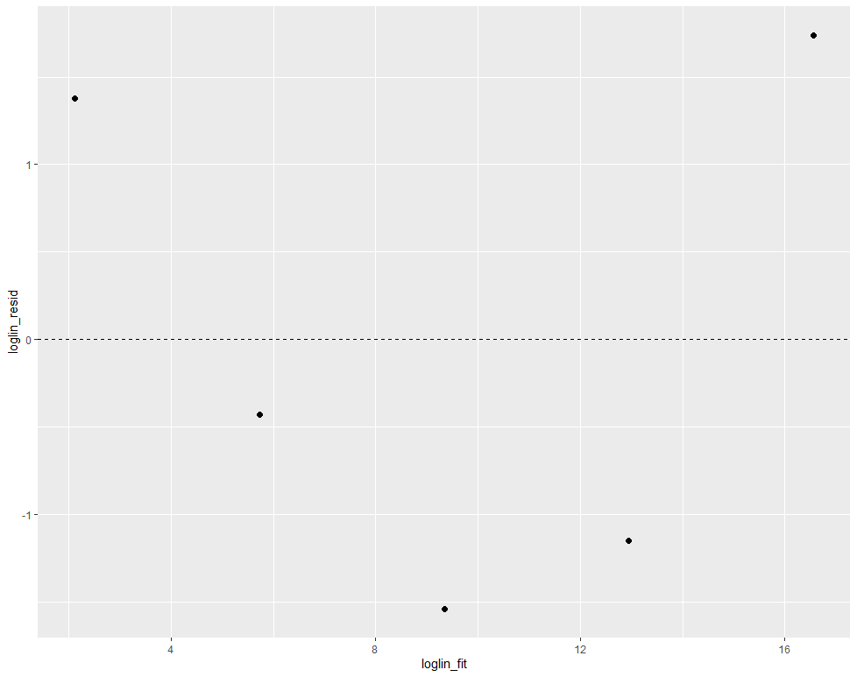
iii. A histogram of residuals with the normal distribution superimposed.
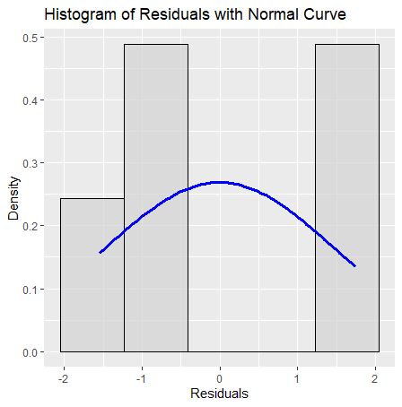vs. 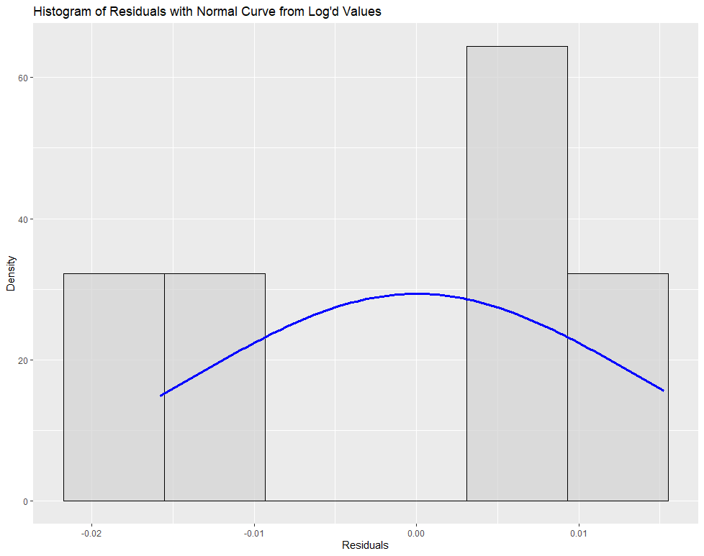
iv. A discussion supporting the use of the model you chose (support that the assumptions are met).
The raw data without transformation seemed to mildly violate the assumptions but not egregiously. Out of curiousity, I decided to plot the Natural Log values of the response variable and discovered that these values fit the assumptions alot better than the untransformed data did. The linearity, almost uncannily on the regression line with a small confidence and prediction interval. The homoscedasticity is hard to determine without more data points, but we will proceed assuming that it’s met albeit cautiously. The distribution of the residuals appears to be approximately normal. It is difficult to say whether each data point affects the other without domain knowledge, but we will continue with the assumption that it’s met.
  - Once a reasonable model is found (possibly using a transformation), provide a table showing the t-statistics and p-values for the significance of the regression parameters $β_{0 }and β_{1}$.
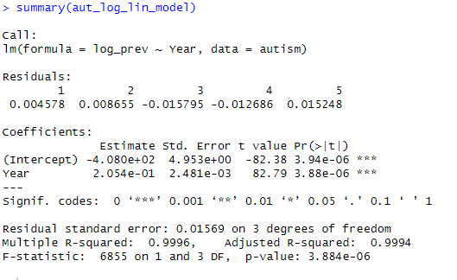

  - The estimate regression equation. Make sure the dependent variable is noted as the predicted value or predicted mean value, not just the dependent variable.
$log(Prevalence) =β_{0 }+β_{1} * Year$
$log(Prevalence) =-4.1+.205 * Year$
  - Interpretation of the model, paying special attention if you used a transformation (hint!). That is, interpret the slope as well as the confidence interval.
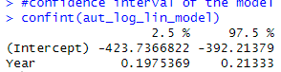
For every year that passes,We are 95% confidence that there is an associated increase of .197 - .213 to the median of the prevalence rate of autism.

  - A measure of the proportion of variation in the response that is accounted for by the explanatory variable. Interpret this measure clearly.
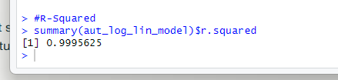

99% of the variation of the prevalence rate is explained by the increase of the years. This doesn’t show that necessarily that the literal passing of time is increasing autism in children, but that there is an associated increase to the median prevalance of autism as each year passes.

Code for Problem 2
#Unit 11 Homework
#Gathering Data
autism <- read.csv(file.choose())
autism

#transform the data
autism$log_prev <- log(autism$Prevalence)
autism$log_year <- log(autism$Year)

#Model
aut_model <- lm(Prevalence ~ Year, data = autism)
aut_log_lin_model <- lm(log_prev ~ Year, data = autism)

#Confidence and Prediction Model
aut_conf <- predict(aut_model, newdata = autism, interval = "confidence")
aut_pred <- predict(aut_model, newdata = autism, interval = "prediction")

aut_loglin_conf <- predict(aut_log_lin_model, newdata = autism, interval = "confidence")
aut_loglin_pred <- predict(aut_log_lin_model, newdata = autism, interval = "prediction")

#plotting the data
library(ggplot2)
aut_plot <- cbind(autism, aut_conf, aut_pred = aut_pred[,"upr"], aut_pred_lwr = aut_pred[,"lwr"])
aut_loglin_plot <- cbind(autism, aut_loglin_conf, aut_loglin_pred = aut_loglin_pred[,"upr"], aut_loglin_pred_lwr = aut_loglin_pred[,"lwr"])

ggplot(autism, aes(x= Year, y = Prevalence)) +
geom_point(size = 2) +
geom_smooth(method = "lm", se = TRUE, color = "blue", fill = "lightblue") +
geom_line(data = aut_plot, aes(y = fit), color = "blue") +
geom_ribbon(data = aut_plot, aes(ymin = lwr, ymax = upr), alpha = 0.2, fill = "blue") +
geom_ribbon(data = aut_plot, aes(ymin = aut_pred_lwr, ymax = aut_pred), alpha = 0.1, fill = "red") +
ggtitle("Year vs. Autism Prevalence") +
ylab("Prevalence per 10,000")

ggplot(autism, aes(x= Year, y = log_prev)) +
geom_point(size = 2) +
geom_smooth(method = "lm", se = TRUE, color = "blue", fill = "lightblue") +
geom_line(data = aut_loglin_plot, aes(y = fit), color = "blue") +
geom_ribbon(data = aut_loglin_plot, aes(ymin = lwr, ymax = upr), alpha = 0.2, fill = "blue") +
geom_ribbon(data = aut_loglin_plot, aes(ymin = aut_loglin_pred_lwr, ymax = aut_loglin_pred), alpha = 0.1, fill = "red") +
ggtitle("Year vs. Log'd Autism Prevalence") +
ylab("Prevalence per 10,000")

#Resdiuals and Residual Plot
autism$residuals <- resid(aut_model)
autism$fitted <- fitted(aut_model)

autism$loglin_resid <- resid(aut_loglin_plot)
autism$loglin_fit <- fitted(aut_loglin_plot)

ggplot(autism, aes(x = fitted, y = residuals)) +
geom_point(size = 2) +
geom_hline(yintercept = 0, linetype = "dashed", x = "Fitted Values", y = "Residuals")

ggplot(autism, aes(x = loglin_fit, y = loglin_resid)) +
geom_point(size = 2) +
geom_hline(yintercept = 0, linetype = "dashed", x = "Fitted Values", y = "Residuals")

#Histogram with Normal Curve
ggplot(autism, aes(x=residuals)) +
geom_histogram(aes(y= ..density..), bins = 5, fill = "lightgray", color = "black", alpha = 0.7) +
stat_function(
fun = dnorm,
args = list(mean = mean(autism$residuals), sd = sd(autism$residuals)),
color = "blue",
size = 1.2
)

# Extract residuals from the model
autism$residuals <- resid(model)
df <- data.frame(residuals = autism$residuals)

ggplot(df, aes(x = residuals)) +
geom_histogram(aes(y = ..density..), bins = 5, fill = "lightgray", color = "black", alpha = 0.7) +
stat_function(fun = dnorm, args = list(mean = mean(df$residuals), sd = sd(df$residuals)), color = "blue", size = 1.2) +
labs(title = "Histogram of Residuals with Normal Curve", x = "Residuals", y = "Density")

autism$loglin_resid <- resid(aut_log_lin_model)
loglin_df <- data.frame(residuals = autism$loglin_resid)

ggplot(loglin_df, aes(x = residuals)) +
geom_histogram(aes(y = ..density..), bins = 6, fill = "lightgray", color = "black", alpha = 0.7) +
stat_function(fun = dnorm, args = list(mean = mean(loglin_df$residuals), sd = sd(loglin_df$residuals)), color = "blue", size = 1.2) +
labs(title = "Histogram of Residuals with Normal Curve from Log'd Values", x = "Residuals", y = "Density")

#summary of chosen model
summary(aut_log_lin_model)

#confidence interval of the model
confint(aut_log_lin_model)

#R-Squared
summary(aut_log_lin_model)$r.squared
- Bonus!
Consider the steer data in Display 7.3 on page 179 (Chapter 7) of the textbook (third edition). Perform a lack of fit test comparing the regression model and a separate means model. Because we have at least two points in at least one group (replication to estimate the variance), we can perform ANOVA. (ANOVA does not make sense if no values of the independent variable are repeated.) During live session, we already addressed the assumptions and determined that a linear-log model is best for regression. Perform this lack of fit test (all parts) on the transformed data. Use the software of your choice. Specifically, include the following:
  - Hypotheses
  - The ANOVA table you created
  - Decision
d. Conclusion in nonstatistical terms
e. Code and relevant output

